The importance of Values in Long term planning

What are Values all about?
A set of values is designed to clearly state what your Association believes deeply in, how it will treat people in the course of its operations, and what your Association really cares about. It acts as a beacon, particularly in times of uncertainty and conflict.

Why does our Association need a Set of Values?
The set of values helps guide both your Strategic Plan and what to do when there isn’t a rule or established policy in place. For example, your Association’s values might include “sportsmanship”. If your Association truly values this, you might have a code of conduct that is actively displayed, as well as annual sportsmanship awards. If one of your top players is seen to be breaking Softball etiquette, your Association might take a hard line with them as opposed to ignoring the behaviour.
The benefits of having an agreed set of values statement include:
- Helping focus your Association on “ doing the right thing”;
- Ensuring transparency, accountability and organisational commitment;
- Having an additional guide during decision making;
- Allowing rewards or discipline to be based on agreed appropriate behaviour;
- Inspire us; and
- Empower the organisation to ‘walk the talk’.

What does a Set of Values look like?
Organisations will typically have around 4-6 core values. Some will be one word lists, others will have the headline value with a short explanation.
Examples of Sporting organisation values:
SPARC
- We are people-focused - we place strong emphasis on supporting and valuing people;
- SPARC aims to foster whanaungatanga (caring for, and support of one another, like a family) - individuals are valued and able to achieve their full potential;
- We strive for excellence - we see ourselves as a nimble, innovative and dynamic organisation. By developing excellent internal processes, we will ensure our ongoing viability and success;
- We demonstrate leadership - as the lead agency in the sport and physical recreation sector, people and organisations look to SPARC to provide leadership and direction. Our goal is to provide effective, focused and inspiring leadership; and
- We display integrity - we aim to demonstrate integrity by ensuring we act ethically and professionally in everything we do.

Swimming New Zealand Values:
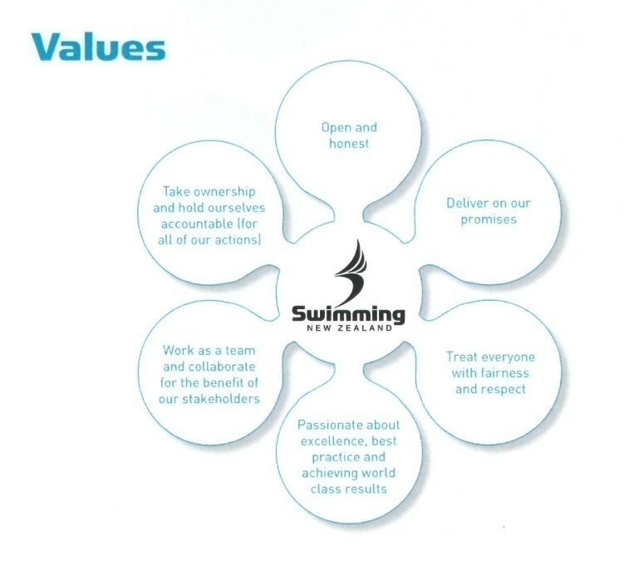
Please contact your local Softball New Zealand (SNZ) Regional Game Development Officer (RGDO) for further Strategic Planning assistance. RGDO contact details are available on the SNZ website – www.softball.org.nz

